“I was losing interest in politics, when the repeal of the
Missouri Compromise aroused me again.”
--Abraham Lincoln, December 20, 1859
Hon. R. Yates, Springfield,
Jacksonville, Ill. August 18, 1854.
My dear Sir:

I am disappointed at not having seen or heard from you since I met you more than a week ago at the railroad depot here. I wish to have the matter we spoke of settled and working to its consummation. I understand that our friend B. S. Edwards is entirely satisfied now, and when I can assure myself of this perfectly I would like, by your leave, to get an additional paragraph into the Journal, about as follows:

“To-day we place the name of Hon. Richard Yates at the head of our columns for reelection as the Whig candidate for this congressional district. We do this without consultation with him and subject to the decision of a Whig convention, should the holding of one be deemed necessary; hoping, however, there may be unanimous acquiescence without a convention.”

May I do this? Answer by return mail.
Yours, as ever, A. LINCOLN.

“HON. RICHARD YATES. Has yielded to the solicitation of his friends and consented to be a candidate for re-election to Congress, subject to the decision of a convention should one be held.”
--(Springfield) Illinois Daily Journal, August 22, 1854, p. 2:1.
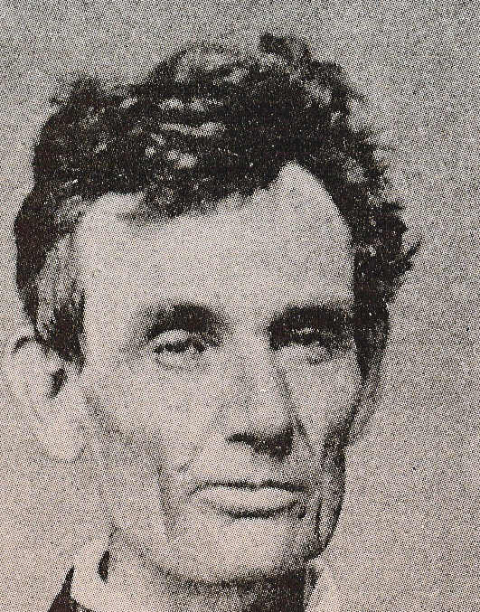
Fig. 2 Lincoln at age 45

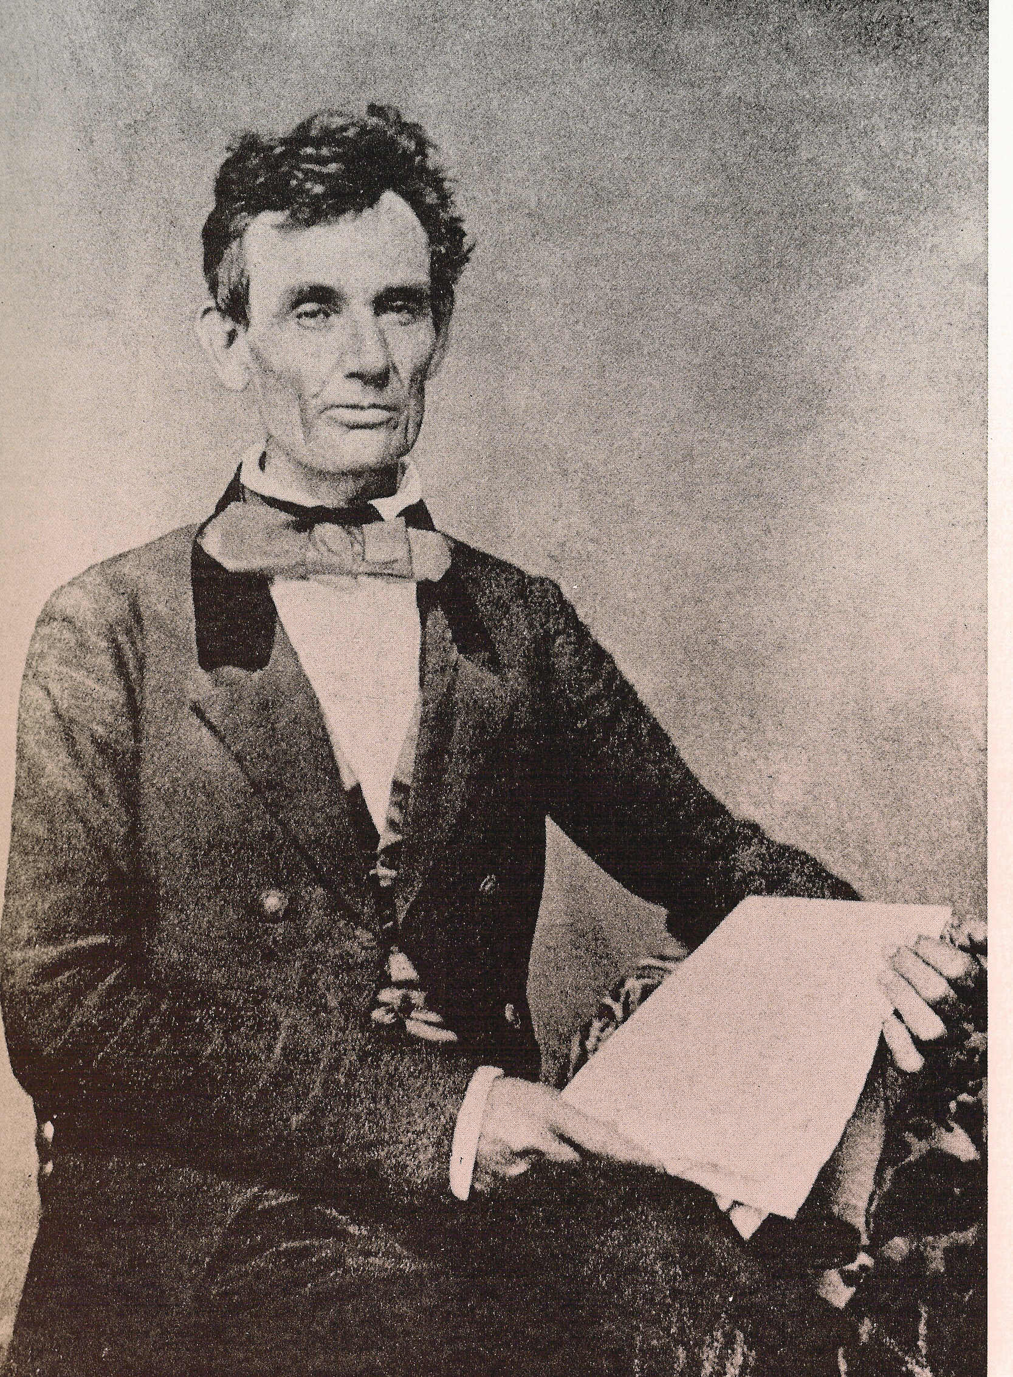
Fig. 1 Abraham Lincoln in 1854
(Chicago, Polycarpus von Schneidau)

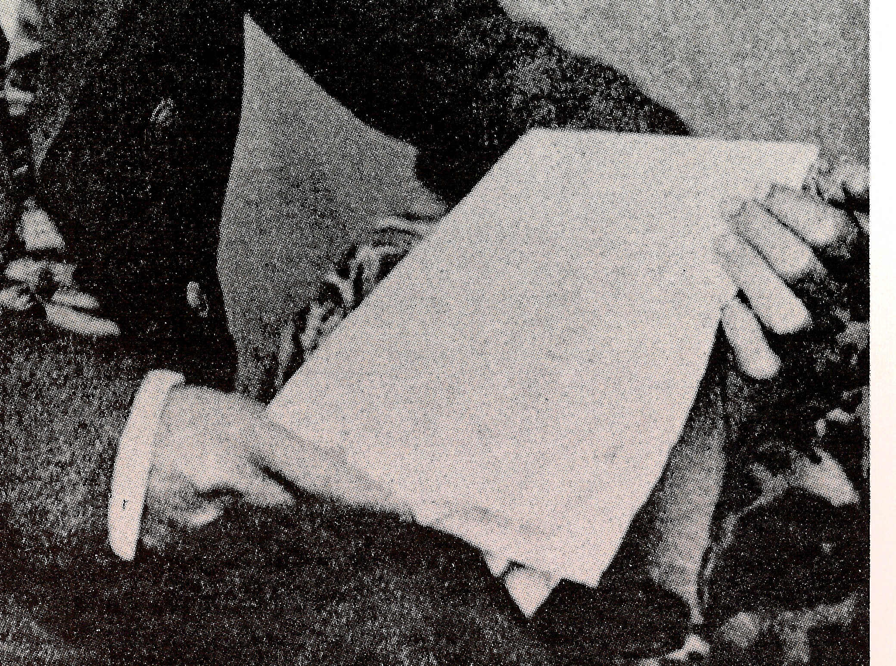
Fig. 3 Holding a copy of the Chicago Democrat

