Black Soldiers in the Civil War

“Once let the black man get upon his person the brass letters U.S., let him get an eagle on his button, and a musket on his shoulder, and bullets in his pocket, and there is no power on earth or under the earth which can deny that he has earned the right of citizenship in the United States.”
--Frederick Douglass, “Should the Negro Enlist in the Union Army,” July 6, 1863

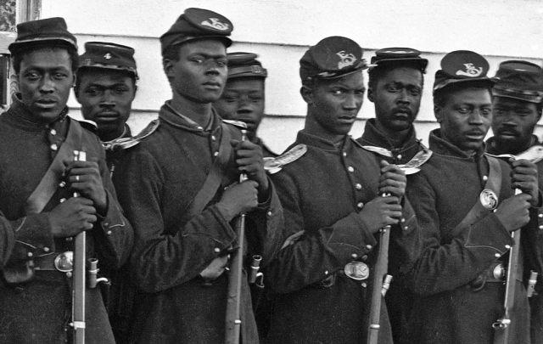
Men of Company E, 4th USCT at Fort Lincoln, Washington DC, 1865 (Library of Congress)

For a good overview on the USCT, see http://www.archives.gov/education/lessons/blacks-civil-war/ and don’t miss the video documentary, “Henry W. Spradley, Citizen,” from the House Divided Project: http://www.youtube.com/hdivided

Susie King Taylor (1848-1912)
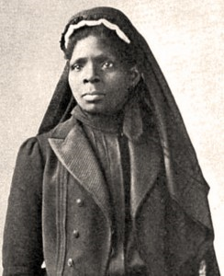
Susie Baker King Taylor was the first African American to teach openly in a school for former slaves in Georgia. As the author of Reminiscences of My Life in Camp with the 33d United States Colored Troops, Late 1st S.C. Volunteers, she was the only African American woman to publish a memoir of her wartime experiences.
--From the New Georgia Encyclopedia

What about Black Confederates?
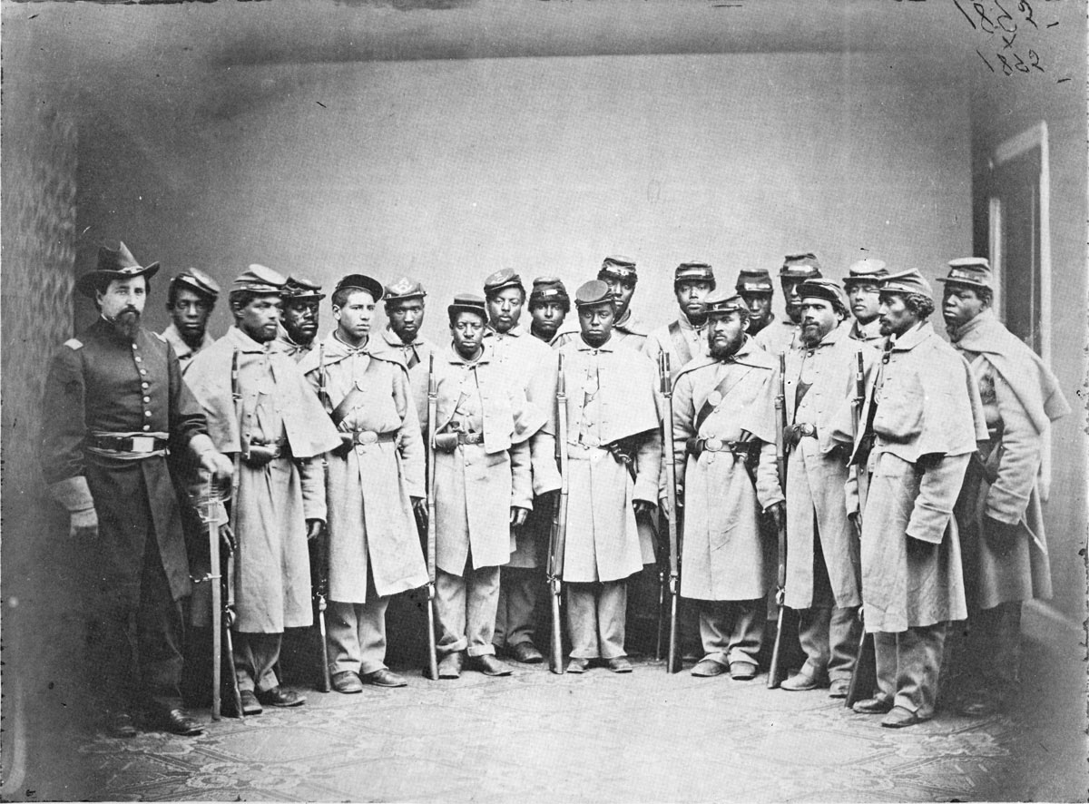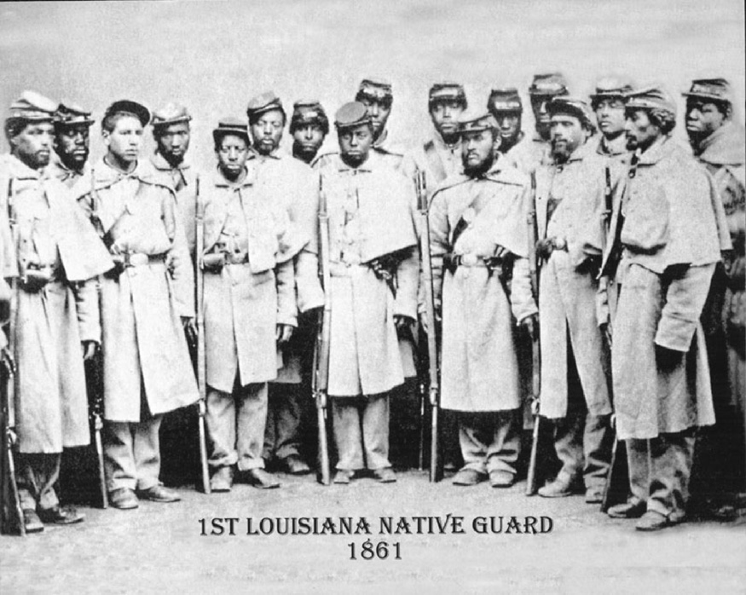
Figure 1 Union soldiers in Philadelphia, 1864 Figure 2 As cropped by RebelStore.com
See http://www.retouchinghistory.org/ for more details

