Samuel Wilkeson and the Second Birth of Freedom in America
Samuel Wilkeson was a prominent journalist serving as a war correspondent for the New York Times in 1863. Wilkeson’s oldest son Bayard was an artillery officer who had lied about his age to join the Union army and was mortally wounded on the first day of the Battle of Gettysburg, at a place known today as Barlow’s Knoll. Left behind by surgeons fleeing the oncoming Confederates, Lt. Wilkeson (19-years-old) was forced to amputate his own shattered leg and apparently died later from shock. Correspondent Samuel Wilkeson, who was married to Elizabeth Cady Stanton’s sister Catherine, recovered his son’s body in the battle’s aftermath and wrote a famous report in the Times which appeared on July 6. This report was then redistributed as a popular pamphlet under the title: Samuel Wilkeson's Thrilling Word Picture Of Gettysburgh.

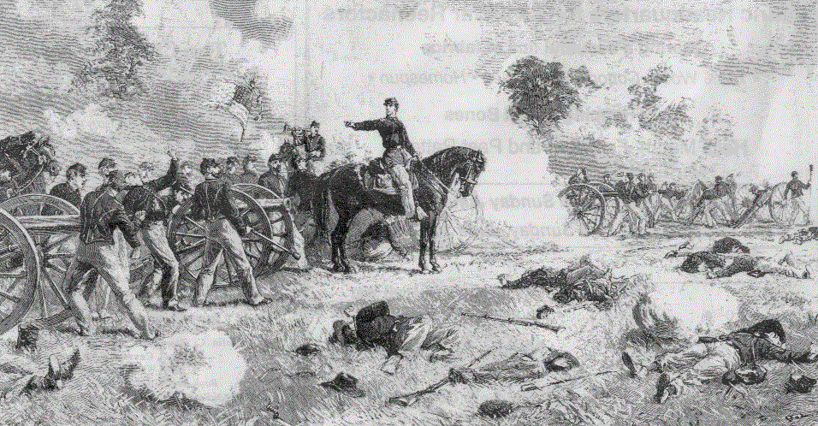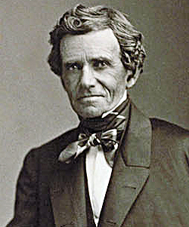
Lt. Bayard Wilkeson (left) at Gettysburg, July 1st (By Alfred Waud); Sam Wilkeson (right)

Here is the opening of Wilkeson’s Gettysburg dispatch, New York Times, July 6, 1863:
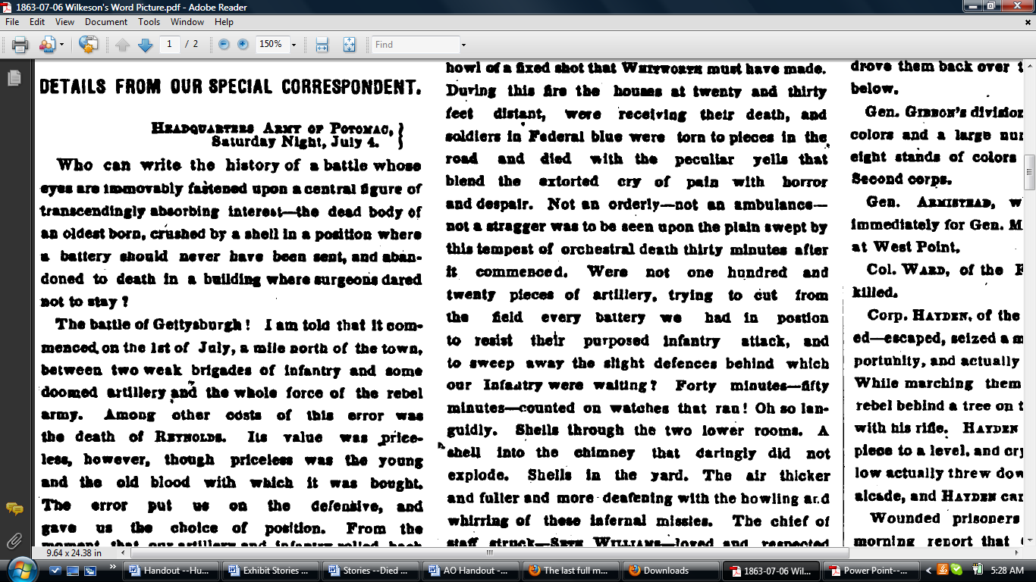

And here is how Wilkeson chose to close his stirring dispatch from July 6:

“My pen is heavy. Oh, you dead, who at Gettysburgh have baptised with your blood the second birth of Freedom in America, how you are to be envied!”

Just over four months later, standing on a hill not far from where young Bayard Wilkeson had died, Abraham Lincoln invoked a similar sentiment:

“We here highly resolve that these dead shall not have died in vain -- that this nation, under God, shall have a new birth of freedom.”

