Abraham Lincoln and Thaddeus Stevens
“A compass, I learnt when I was surveying, it’ll - it’ll point you True North from where you’re standing, but it’s got no advice about the swamps and deserts and chasms.”
--From “Lincoln” (2012), directed by Steven Spielberg, screenplay by Tony Kushner
_____________________________________________________________________
Washington, Sept 3. 1848
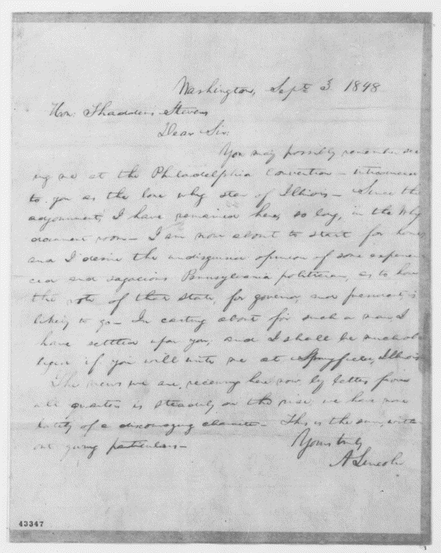
Dear Sir:
You may possibly remember seeing me at the Philadelphia Convention -- introduced to you as the lone whig star of Illinois. Since the adjournment, I have remained here, so long, in the Whig document room. I am now about to start for home; and I desire the undisguised opinion of some experienced and sagacious Pennsylvania politician, as to how the vote of that state, for governor, and president, is likely to go. In casting about for such a man, I have settled upon you; and I shall be much obliged if you will write me at Springfield, Illinois.
The news we are receiving here now, by letters from all quarters is steadily on the rise; we have none lately of a discouraging character. This is the sum, without giving particulars.
Yours truly
A Lincoln

