Lessons from Henry “Box” Brown’s Journey

In March 1849, a slave named Henry Brown escaped from Richmond, Virginia hidden inside a box shipped by Adams Express. Just over twenty-four hours later, he arrived in Philadelphia and became a free man. Within a few months, the “resurrection” of Henry “Box” Brown was well known. However, the full lessons of Brown’s journey have remained obscured. His experience illustrates much about the operations of the Underground Railroad.
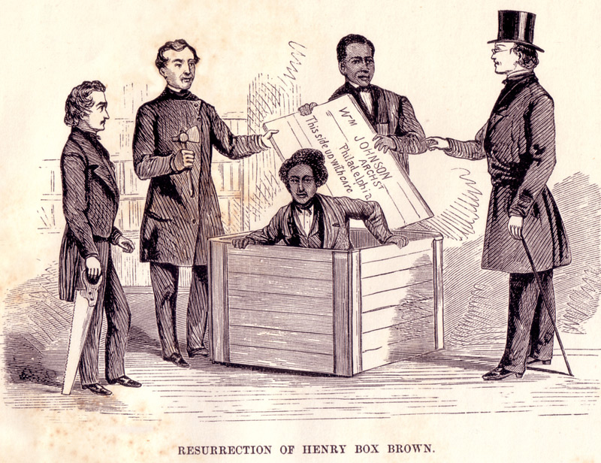

1. The break-up of slave families was a prime motivation for escape.
Different masters owned Henry Brown and his wife. In August 1848, Nancy Brown’s master sold her while she was pregnant, along with her other three children, into the Deep South for just over one thousand dollars. Brown had begged his own master, “my Christian master” he called him, to purchase his family, but the man had told him, “You can get another wife.” Distraught, Brown began plotting desperately to escape from bondage.

2. The Underground Railroad was often national in scope.
One of Brown’s white friends and allies in Richmond, shoemaker Samuel A. Smith, traveled to Philadelphia in the beginning of March 1849 to make arrangements with Anti-Slavery Society officials in the northern city. The meeting and the coordinated efforts between the two cities, and the subsequent transfer of Brown north from Philadelphia to New York and eventually to New Bedford, Massachusetts, was always planned and arranged in advance and illustrates an inter-state network of impressive dimensions. Brown’s later relocation to England in 1850 following passage of the new fugitive slave law, also indicates the degree to which the abolitionist network was sometimes international in scope as well.

3. Blacks and whites worked together to help slaves escape.
In Richmond, Brown received help from at least two men, James C.A. Smith, a free black man, and Samuel A. Smith, a white storeowner. The latter Smith was a shoemaker who had once owned slaves himself. The Anti-Slavery Society agents who helped arrange Brown’s rescue included white men such as James Miller McKim, a Presbyterian minister, and William Still, a free black man originally from New Jersey.

4. The gravest dangers in helping runaways came to southern agents.
The only person who went to jail for being involved in the dramatic escape of Henry Brown was Samuel A. Smith, who served six-and-a-half years in the Virginia State Penitentiary, following his convictions in October and November 1849.

5. Fugitives and Underground Railroad agents were heroes --and humans.
Historians and teachers who celebrate the bravery and accomplishments of those involved in the effort to destroy slavery might also be wary not to romanticize them. These men and women were human heroes, with both good and bad traits. Henry Brown and James C.A. Smith, for example, had a falling out over money while touring in England. Smith accused Brown of stealing from him, and of failing to try hard enough to purchase freedom for his wife and children.

Sources: Jeffrey Ruggles, The Unboxing of Henry Brown (Richmond: Library of Virginia, 2003). Photo credit: William Still, The Underground Railroad (Philadelphia: Porter & Coates, 1872).

