Battle of Gettysburg // Bureau of Military Information

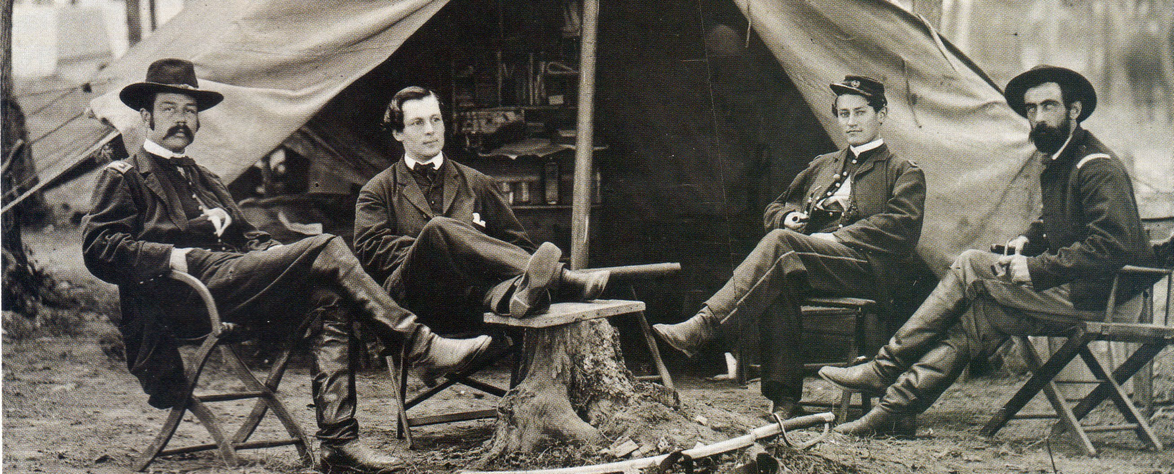
From left to right: George H. Sharpe, John Babcock, an unidentified clerk, and John McEntee, c. 1863

INFORMATION GATHERING
“…an order from General Lee was very lately read to the troops announcing a campaign of long marches & hard fighting in a part of the country where they would have no railroad transportation.”
--Col. George H. Sharpe reporting to Gen. Joseph Hooker, May 27, 1863
INFORMATION ANALYSIS “Prisoners have been taken today, and last evening, from every brigade in Lee’s Army excepting the four brigades of Pickett’s Division…Pickett’s division has come up and is now in bivouac, and will be ready to go into action fresh tomorrow morning.” --Col. George H. Sharpe to Gen. George G. Meade, July 2, 1863

