Classic Gettysburg Maps

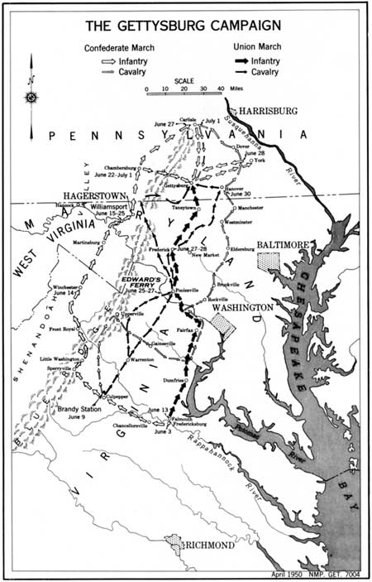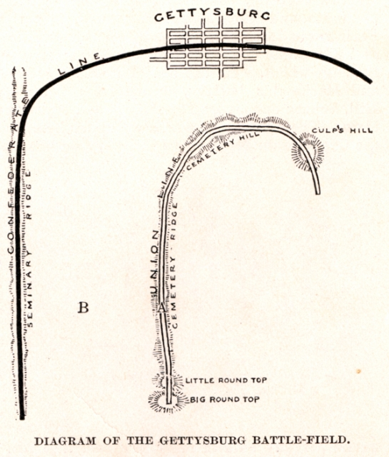
NPS Gettysburg Campaign Handbook (1950) Battles and Leaders Fishhook Diagram (1894)

