Battle of Gettysburg // Day Three (Pickett’s Charge)
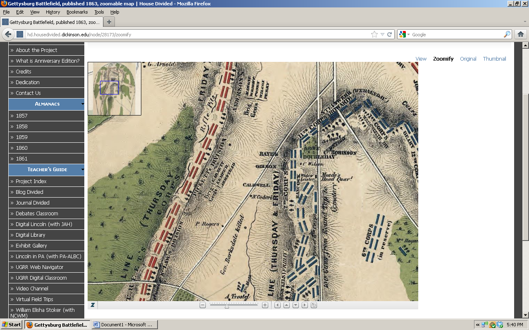
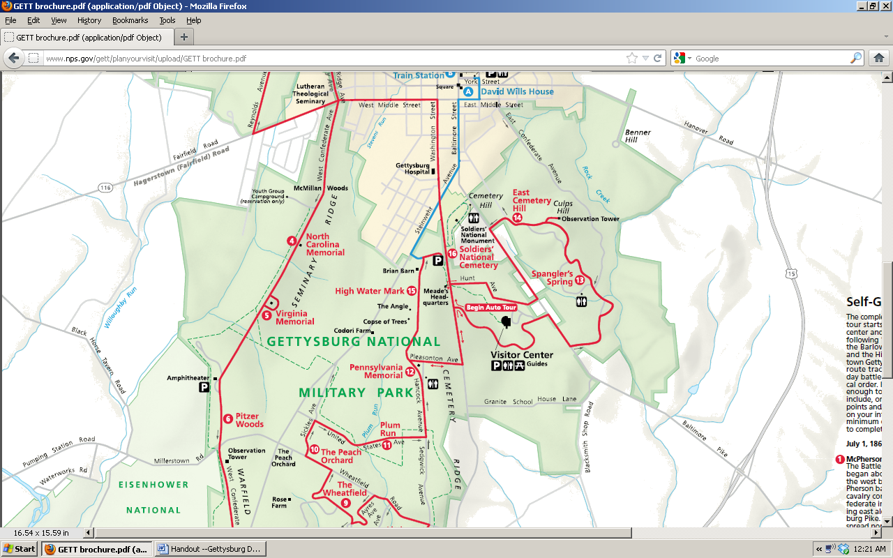

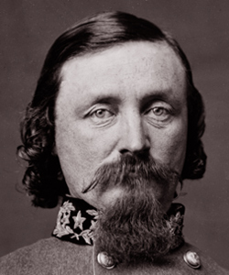
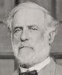
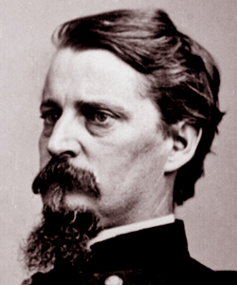
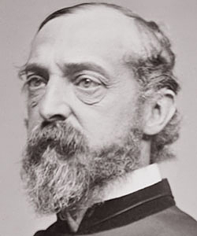
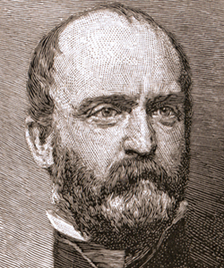
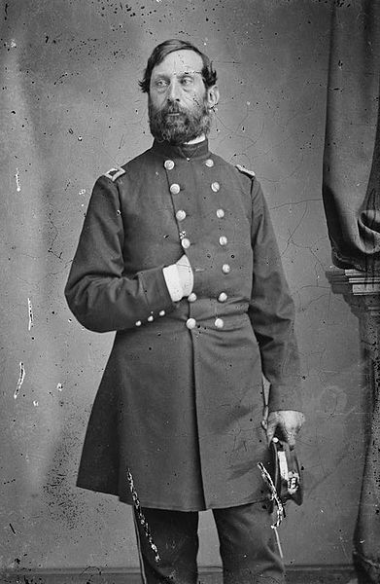

Robert E. Lee Lewis Armistead George Pickett Henry J. Hunt Winfield Hancock George G. Meade

(Image Credits: National Park Service, Library of Congress, House Divided Project at Dickinson College)

