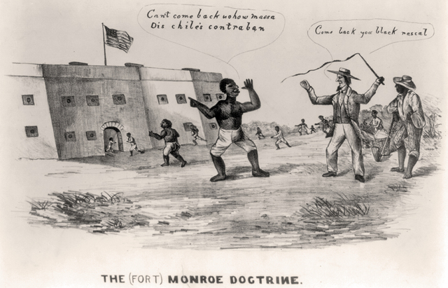
“The Fort Monroe Doctrine” cartoon

In May 1861, three Confederate slaves ran away to Union-controlled Fort Monroe on the Virginia peninsula. Gen. Benjamin Butler refused to return the men. The War Department then approved treating them as “contraband of war.” On August 6, Congress sanctioned this policy of seizing and (in effect) freeing wartime “contrabands” with passage of the First Confiscation Act.

The Emancipation Proclamation issued on January 1, 1863, carefully designated which areas of the country were still in rebellion and thus subject to Lincoln’s military emancipation. From now on, Union army officials had to free all slaves in rebellious areas, not simply accept “contrabands” or punish Confederate masters. The decree also authorized black recruits for the federal military.

The lame-duck 38th Congress adopted a new constitutional amendment prohibiting slavery on January 31, 1865. President Lincoln signed the next day and enough states approved to succeed in ratifying the Thirteenth Amendment by Dec.1865. Slavery was finally abolished in the United States.
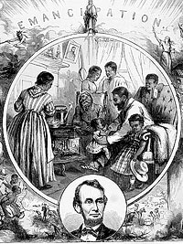
Emancipation print

18617
1862
1863
1864
1865
During the election of 1864, Republicans pledged to abolish slavery everywhere, immediately and without compensation to masters, through a constitutional amendment. They were unsuccessful at the federal level that year, but did push Border States such as Maryland and Missouri to begin the process of abolition.

First Reading of Emancipation Proclamation

Men of Company E, 1865

“Union and Liberty,” 1864 cartoon

After facing more pressure from commanders such as Butler and after Congress passed a Second Confiscation Act promising to make all Confederate-owned slaves “forever free,” President Lincoln decided by July 22, 1862 that he had to take control of emancipation policy. He read a first draft of a military proclamation to his cabinet but delayed announcing his plans to the public until September 22, 1862 –after the Union victory at the Battle of Antietam.

